Virtualization in Cloud Computing
Virtualization is the "creation of a virtual (rather than actual) version of something, such as a server, a desktop, a storage device, an operating system or network resources".
In other words, Virtualization is a technique, which allows to share a single physical instance of a resource or an application among multiple customers and organizations. It does by assigning a logical name to a physical storage and providing a pointer to that physical resource when demanded.

What is the concept behind the Virtualization?
Creation of a virtual machine over existing operating system and hardware is known as Hardware Virtualization. A Virtual machine provides an environment that is logically separated from the underlying hardware.
The machine on which the virtual machine is going to create is known as Host Machine and that virtual machine is referred as a Guest Machine

Types of Virtualization:
- Hardware Virtualization.
- Operating system Virtualization.
- Server Virtualization.
- Storage Virtualization.

1) Hardware Virtualization:
When the virtual machine software or virtual machine manager (VMM) is directly installed on the hardware system is known as hardware virtualization.
The main job of hypervisor is to control and monitoring the processor, memory and other hardware resources.
After virtualization of hardware system we can install different operating system on it and run different applications on those OS.
Usage:
Hardware virtualization is mainly done for the server platforms, because controlling virtual machines is much easier than controlling a physical server.

2) Operating System Virtualization:
When the virtual machine software or virtual machine manager (VMM) is installed on the Host operating system instead of directly on the hardware system is known as operating system virtualization.
Usage:
Operating System Virtualization is mainly used for testing the applications on different platforms of OS.

3) Server Virtualization:
When the virtual machine software or virtual machine manager (VMM) is directly installed on the Server system is known as server virtualization.
Usage:
Server virtualization is done because a single physical server can be divided into multiple servers on the demand basis and for balancing the load.

4) Storage Virtualization:
Storage virtualization is the process of grouping the physical storage from multiple network storage devices so that it looks like a single storage device.
Storage virtualization is also implemented by using software applications.
Usage:
Storage virtualization is mainly done for back-up and recovery purposes.

How does virtualization work in cloud computing?
Virtualization plays a very important role in the cloud computing technology, normally in the cloud computing, users share the data present in the clouds like application etc, but actually with the help of virtualization users shares the Infrastructure.
The main usage of Virtualization Technology is to provide the applications with the standard versions to their cloud users, suppose if the next version of that application is released, then cloud provider has to provide the latest version to their cloud users and practically it is possible because it is more expensive.
To overcome this problem we use basically virtualization technology, By using virtualization, all severs and the software application which are required by other cloud providers are maintained by the third party people, and the cloud providers has to pay the money on monthly or annual basis.
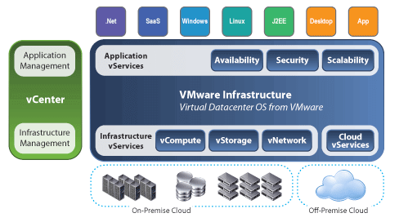

Conclusion
Mainly Virtualization means, running multiple operating systems on a single machine but sharing all the hardware resources. And it helps us to provide the pool of IT resources so that we can share these IT resources in order get benefits in the business.
Next →← Prev

Data Virtualization
Data virtualization is the process of retrieve data from various resources without knowing its type and physical location where it is stored. It collects heterogeneous data from different resources and allows data users across the organization to access this data according to their work requirements. This heterogeneous data can be accessed using any application such as web portals, web services, E-commerce, Software as a Service (SaaS), and mobile application.
We can use Data Virtualization in the field of data integration, business intelligence, and cloud computing.

Advantages of Data Virtualization
There are the following advantages of data virtualization -
- It allows users to access the data without worrying about where it resides on the memory.
- It offers better customer satisfaction, retention, and revenue growth.
- It provides various security mechanism that allows users to safely store their personal and professional information.
- It reduces costs by removing data replication.
- It provides a user-friendly interface to develop customized views.
- It provides various simple and fast deployment resources.
- It increases business user efficiency by providing data in real-time.
- It is used to perform tasks such as data integration, business integration, Service-Oriented Architecture (SOA) data services, and enterprise search.

Disadvantages of Data Virtualization
- It creates availability issues, because availability is maintained by third-party providers.
- It required a high implementation cost.
- It creates the availability and scalability issues.
- Although it saves time during the implementation phase of virtualization but it consumes more time to generate the appropriate result.

Uses of Data Virtualization
There are the following uses of Data Virtualization -

1. Analyze performance
Data virtualization is used to analyze the performance of the organization compared to previous years.

2. Search and discover interrelated data
Data Virtualization (DV) provides a mechanism to easily search the data which is similar and internally related to each other.

3. Agile Business Intelligence
It is one of the most common uses of Data Virtualization. It is used in agile reporting, real-time dashboards that require timely aggregation, analyze and present the relevant data from multiple resources. Both individuals and managers use this to monitor performance, which helps to make daily operational decision processes such as sales, support, finance, logistics, legal, and compliance.

4. Data Management
Data virtualization provides a secure centralized layer to search, discover, and govern the unified data and its relationships.

Data Virtualization Tools
There are the following Data Virtualization tools -

1. Red Hat JBoss data virtualization
Red Hat virtualization is the best choice for developers and those who are using micro services and containers. It is written in Java.

2. TIBCO data virtualization
TIBCO helps administrators and users to create a data virtualization platform for accessing the multiple data sources and data sets. It provides a builtin transformation engine to combine non-relational and un-structured data sources.

3. Oracle data service integrator
It is a very popular and powerful data integrator tool which is mainly worked with Oracle products. It allows organizations to quickly develop and manage data services to access a single view of data.

4. SAS Federation Server
SAS Federation Server provides various technologies such as scalable, multi-user, and standards-based data access to access data from multiple data services. It mainly focuses on securing data.

5. Denodo
Denodo is one of the best data virtualization tools which allows organizations to minimize the network traffic load and improve response time for large data sets. It is suitable for both small as well as large organizations.

Industries that use Data Virtualization
- Communication & Technology
In Communication & Technology industry, data virtualization is used to increase revenue per customer, create a real-time ODS for marketing, manage customers, improve customer insights, and optimize customer care, etc.
- Finance
In the field of finance, DV is used to improve trade reconciliation, empowering data democracy, addressing data complexity, and managing fixed-risk income.
- Government
In the government sector, DV is used for protecting the environment.
- Healthcare
Data virtualization plays a very important role in the field of healthcare. In healthcare, DV helps to improve patient care, drive new product innovation, accelerating M&A synergies, and provide a more efficient claims analysis.
- Manufacturing
In manufacturing industry, data virtualization is used to optimize a global supply chain, optimize factories, and improve IT assets utilization.

Hardware Virtualization
Previously, there was "one to one relationship" between physical servers and operating system. Low capacity of CPU, memory, and networking requirements were available. So, by using this model, the costs of doing business increased. The physical space, amount of power, and hardware required meant that costs were adding up.
The hypervisor manages shared the physical resources of the hardware between the guest operating systems and host operating system. The physical resources become abstracted versions in standard formats regardless of the hardware platform. The abstracted hardware is represented as actual hardware. Then the virtualized operating system looks into these resources as they are physical entities.
Virtualization means abstraction. Hardware virtualization is accomplished by abstracting the physical hardware layer by use of a hypervisor or VMM (Virtual Machine Monitor).
When the virtual machine software or virtual machine manager (VMM) or hypervisor software is directly installed on the hardware system is known as hardware virtualization.
The main job of hypervisor is to control and monitoring the processor, memory and other hardware resources.
After virtualization of hardware system we can install different operating system on it and run different applications on those OS.

Usage of Hardware Virtualization
Hardware virtualization is mainly done for the server platforms, because controlling virtual machines is much easier than controlling a physical server.

Advantages of Hardware Virtualization
The main benefits of hardware virtualization are more efficient resource utilization, lower overall costs as well as increased uptime and IT flexibility.

1) More Efficient Resource Utilization:
Physical resources can be shared among virtual machines. Although the unused resources can be allocated to a virtual machine and that can be used by other virtual machines if the need exists.

2) Lower Overall Costs Because Of Server Consolidation:
Now it is possible for multiple operating systems can co-exist on a single hardware platform, so that the number of servers, rack space, and power consumption drops significantly.

3) Increased Uptime Because Of Advanced Hardware Virtualization Features:
The modern hypervisors provide highly orchestrated operations that maximize the abstraction of the hardware and help to ensure the maximum uptime. These functions help to migrate a running virtual machine from one host to another dynamically, as well as maintain a running copy of virtual machine on another physical host in case the primary host fails.

4) Increased IT Flexibility:
Hardware virtualization helps for quick deployment of server resources in a managed and consistent ways. That results in IT being able to adapt quickly and provide the business with resources needed in good time.

Software Virtualization
Managing applications and distribution becomes a typical task for IT departments. Installation mechanism differs from application to application. Some programs require certain helper applications or frameworks and these applications may have conflict with existing applications.
Software virtualization is just like a virtualization but able to abstract the software installation procedure and create virtual software installations.
Virtualized software is an application that will be "installed" into its own self-contained unit.
Example of software virtualization is VMware software, virtual box etc. In the next pages, we are going to see how to install linux OS and windows OS on VMware application.

Advantages of Software Virtualization

1) Client Deployments Become Easier:
Copying a file to a workstation or linking a file in a network then we can easily install virtual software.

2) Easy to manage:
To manage updates becomes a simpler task. You need to update at one place and deploy the updated virtual application to the all clients.

3) Software Migration:
Without software virtualization, moving from one software platform to another platform takes much time for deploying and impact on end user systems. With the help of virtualized software environment the migration becomes easier.

Server Virtualization
Server Virtualization is the process of dividing a physical server into several virtual servers, called virtual private servers. Each virtual private server can run independently.
The concept of Server Virtualization widely used in the IT infrastructure to minimizes the costs by increasing the utilization of existing resources.

Types of Server Virtualization

1. Hypervisor
In the Server Virtualization, Hypervisor plays an important role. It is a layer between the operating system (OS) and hardware. There are two types of hypervisors.
- Type 1 hypervisor ( also known as bare metal or native hypervisors)
- Type 2 hypervisor ( also known as hosted or Embedded hypervisors)
The hypervisor is mainly used to perform various tasks such as allocate physical hardware resources (CPU, RAM, etc.) to several smaller independent virtual machines, called "guest" on the host machine.

2. Full Virtualization
Full Virtualization uses a hypervisor to directly communicate with the CPU and physical server. It provides the best isolation and security mechanism to the virtual machines.
The biggest disadvantage of using hypervisor in full virtualization is that a hypervisor has its own processing needs, so it can slow down the application and server performance.
VMWare ESX server is the best example of full virtualization.

3. Para Virtualization
Para Virtualization is quite similar to the Full Virtualization. The advantage of using this virtualization is that it is easier to use, Enhanced performance, and does not require emulation overhead. Xen primarily and UML use the Para Virtualization.
The difference between full and pare virtualization is that, in para virtualization hypervisor does not need too much processing power to manage the OS.

4. Operating System Virtualization
Operating system virtualization is also called as system-lever virtualization. It is a server virtualization technology that divides one operating system into multiple isolated user-space called virtual environments. The biggest advantage of using server visualization is that it reduces the use of physical space, so it will save money.
Linux OS Virtualization and Windows OS Virtualization are the types of Operating System virtualization.
FreeVPS, OpenVZ, and Linux Vserver are some examples of System-Level Virtualization.

Note: OS-Level Virtualization never uses a hypervisor.

5. Hardware Assisted Virtualization
Hardware Assisted Virtualization was presented by AMD and Intel. It is also known as Hardware virtualization, AMD virtualization, and Intel virtualization. It is designed to increase the performance of the processor. The advantage of using Hardware Assisted Virtualization is that it requires less hypervisor overhead.

6. Kernel-Level Virtualization
Kernel-level virtualization is one of the most important types of server virtualization. It is an open-source virtualization which uses the Linux kernel as a hypervisor. The advantage of using kernel virtualization is that it does not require any special administrative software and has very less overhead.
User Mode Linux (UML) and Kernel-based virtual machine are some examples of kernel virtualization.

Advantages of Server Virtualization
There are the following advantages of Server Virtualization -
1. Independent Restart
In Server Virtualization, each server can be restart independently and does not affect the working of other virtual servers.
2. Low Cost
Server Virtualization can divide a single server into multiple virtual private servers, so it reduces the cost of hardware components.
3. Disaster Recovery<
Disaster Recovery is one of the best advantages of Server Virtualization. In Server Virtualization, data can easily and quickly move from one server to another and these data can be stored and retrieved from anywhere.
4. Faster deployment of resources
Server virtualization allows us to deploy our resources in a simpler and faster way.
5. Security
It allows uses to store their sensitive data inside the data centers.

Disadvantages of Server Virtualization
There are the following disadvantages of Server Virtualization -
- The biggest disadvantage of server virtualization is that when the server goes offline, all the websites that are hosted by the server will also go down.
- There is no way to measure the performance of virtualized environments.
- It requires a huge amount of RAM consumption.
- It is difficult to set up and maintain.
- Some core applications and databases are not supported virtualization.
- It requires extra hardware resources.

Uses of Server Virtualization
A list of uses of server virtualization is given below -
- Server Virtualization is used in the testing and development environment.
- It improves the availability of servers.
- It allows organizations to make efficient use of resources.
- It reduces redundancy without purchasing additional hardware components.

Storage Virtualization
As we know that, there has been a strong link between the physical host and the locally installed storage devices. However, that paradigm has been changing drastically, almost local storage is no longer needed. As the technology progressing, more advanced storage devices are coming to the market that provide more functionality, and obsolete the local storage.
Storage virtualization is a major component for storage servers, in the form of functional RAID levels and controllers. Operating systems and applications with device can access the disks directly by themselves for writing. The controllers configure the local storage in RAID groups and present the storage to the operating system depending upon the configuration. However, the storage is abstracted and the controller is determining how to write the data or retrieve the requested data for the operating system.
Storage virtualization is becoming more and more important in various other forms:
File servers: The operating system writes the data to a remote location with no need to understand how to write to the physical media.
Backward Skip 10sPlay VideoForward Skip 10s
WAN Accelerators: Instead of sending multiple copies of the same data over the WAN environment, WAN accelerators will cache the data locally and present the re-requested blocks at LAN speed, while not impacting the WAN performance.
SAN and NAS: Storage is presented over the Ethernet network of the operating system. NAS presents the storage as file operations (like NFS). SAN technologies present the storage as block level storage (like Fibre Channel). SAN technologies receive the operating instructions only when if the storage was a locally attached device.
Storage Tiering: Utilizing the storage pool concept as a stepping stone, storage tiering analyze the most commonly used data and places it on the highest performing storage pool. The lowest one used data is placed on the weakest performing storage pool.
This operation is done automatically without any interruption of service to the data consumer.

Advantages of Storage Virtualization
- Data is stored in the more convenient locations away from the specific host. In the case of a host failure, the data is not compromised necessarily.
- The storage devices can perform advanced functions like replication, reduplication, and disaster recovery functionality.
- By doing abstraction of the storage level, IT operations become more flexible in how storage is provided, partitioned, and protected.

OS Virtualization
With the help of OS virtualization nothing is pre-installed or permanently loaded on the local device and no-hard disk is needed. Everything runs from the network using a kind of virtual disk. This virtual disk is actually a disk image file stored on a remote server, SAN (Storage Area Network) or NAS (Non-volatile Attached Storage). The client will be connected by the network to this virtual disk and will boot with the Operating System installed on the virtual disk.

How does OS Virtualization works?
Components needed for using OS Virtualization in the infrastructure are given below:
The first component is the OS Virtualization server. This server is the center point in the OS Virtualization infrastructure. The server manages the streaming of the information on the virtual disks for the client and also determines which client will be connected to which virtual disk (using a database, this information is stored). Also the server can host the storage for the virtual disk locally or the server is connected to the virtual disks via a SAN (Storage Area Network). In high availability environments there can be more OS Virtualization servers to create no redundancy and load balancing. The server also ensures that the client will be unique within the infrastructure.
Secondly, there is a client which will contact the server to get connected to the virtual disk and asks for components stored on the virtual disk for running the operating system.
The available supporting components are database for storing the configuration and settings for the server, a streaming service for the virtual disk content, a (optional) TFTP service and a (also optional) PXE boot service for connecting the client to the OS Virtualization servers.
As it is already mentioned that the virtual disk contains an image of a physical disk from the system that will reflect to the configuration and the settings of those systems which will be using the virtual disk. When the virtual disk is created then that disk needs to be assigned to the client that will be using this disk for starting. The connection between the client and the disk is made through the administrative tool and saved within the database. When a client has a assigned disk, the machine can be started with the virtual disk using the following process as displayed in the given below Figure: 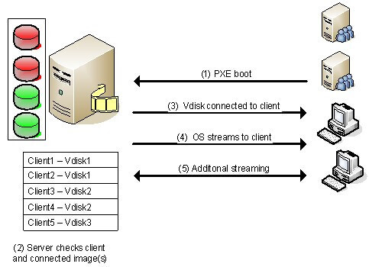

1) Connecting to the OS Virtualization server:
First we start the machine and set up the connection with the OS Virtualization server. Most of the products offer several possible methods to connect with the server. One of the most popular and used methods is using a PXE service, but also a boot strap is used a lot (because of the disadvantages of the PXE service). Although each method initializes the network interface card (NIC), receiving a (DHCP-based) IP address and a connection to the server.

2) Connecting the Virtual Disk:
When the connection is established between the client and the server, the server will look into its database for checking the client is known or unknown and which virtual disk is assigned to the client. When more than one virtual disk are connected then a boot menu will be displayed on the client side. If only one disk is assigned, that disk will be connected to the client which is mentioned in step number 3.

3) VDisk connected to the client:
After the desired virtual disk is selected by the client, that virtual disk is connected through the OS Virtualization server . At the back-end, the OS Virtualization server makes sure that the client will be unique (for example computer name and identifier) within the infrastructure.

4) OS is "streamed" to the client:
As soon the disk is connected the server starts streaming the content of the virtual disk. The software knows which parts are necessary for starting the operating system smoothly, so that these parts are streamed first. The information streamed in the system should be stored somewhere (i.e. cached). Most products offer several ways to cache that information. For examples on the client hard disk or on the disk of the OS Virtualization server.

5) Additional Streaming:
After that the first part is streamed then the operating system will start to run as expected. Additional virtual disk data will be streamed when required for running or starting a function called by the user (for example starting an application available within the virtual disk).

Linux OS Virutualization
Vmware workstation software is used to do the virtualization of Operating System. For installing any Operating System virtually, you need to install VMware software. We are using VMware workstation 10.
Before installing linux OS, you need to have iso image file of linux OS. Let's see the steps to install the linux os virtually.

How to create new virtual machine for linux OS?
1) Click on create new virtual machine.
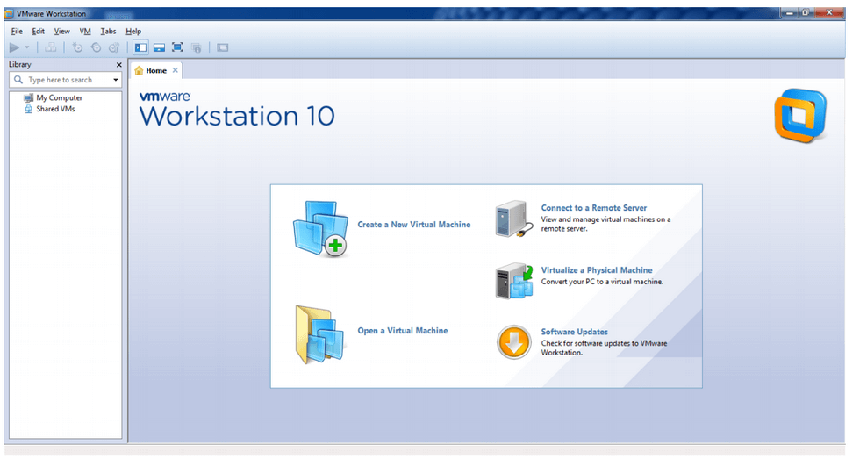
2) In welcome window, choose custom option and click next button.
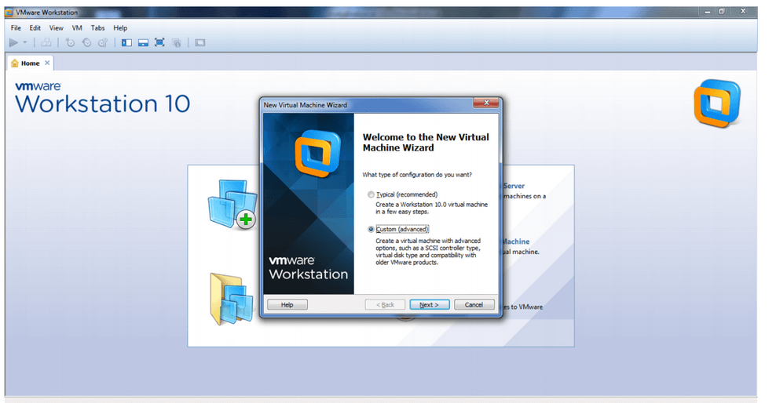
3) In choose the virtual machine hardware compatibility window, click on next button.
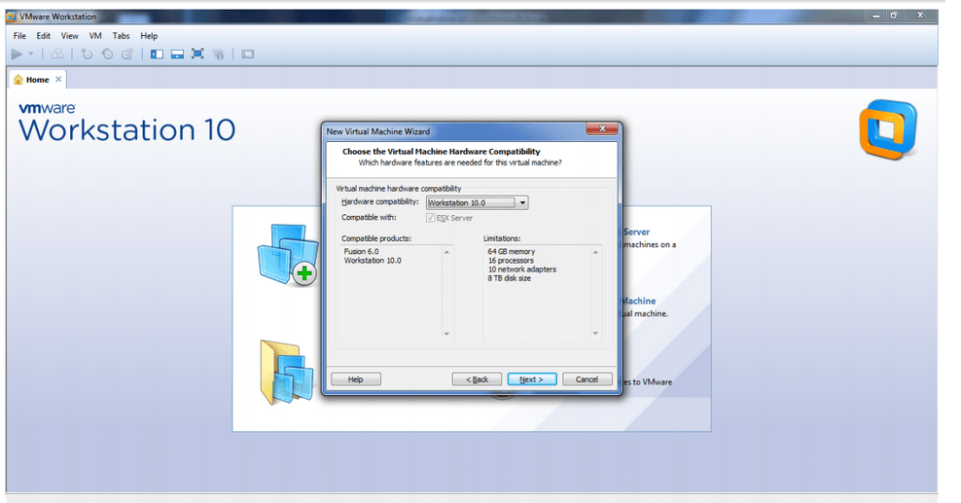
4) In the Guest operating system window, choose iso image file from the disk or any drive. I have put the iso file of ubuntu in e: drive. So browse your iso image and click on next button.
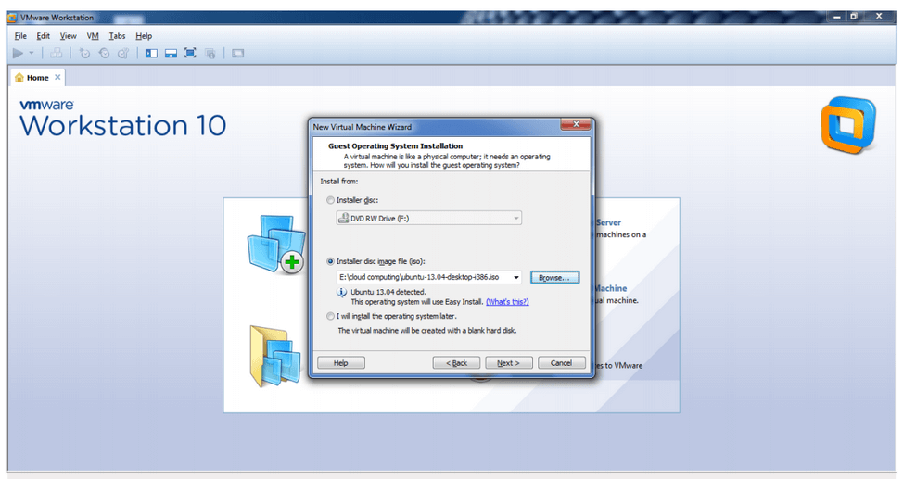
5) In the easy install information window, provide full name, username, password and confirm password then click on next button.
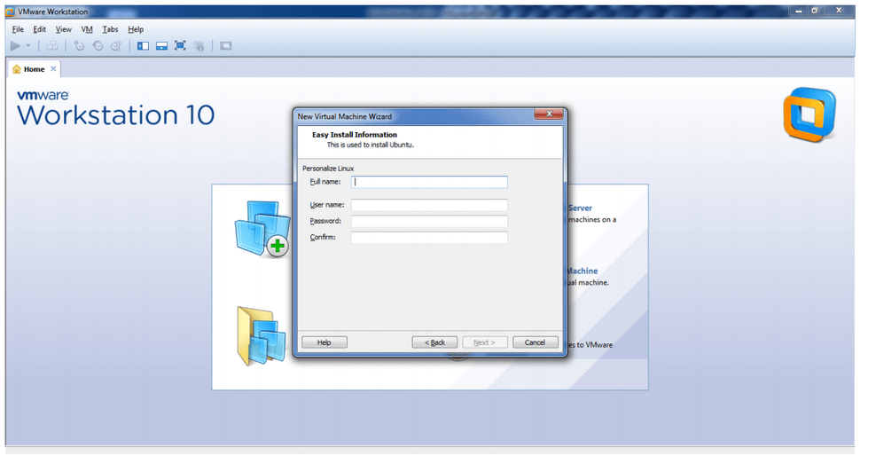
You can see the given information.
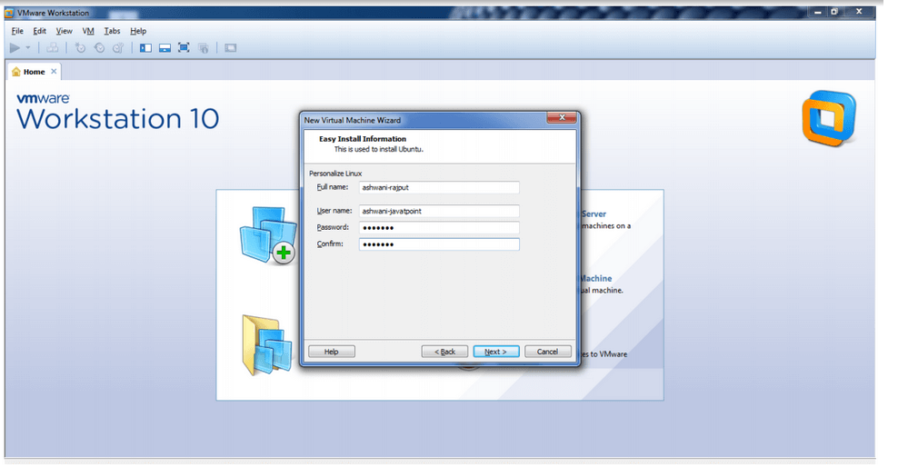
6) In the processor configuration information, you can select number of processors, number of processor per core. If you don't want to change the default settings, click on next only.
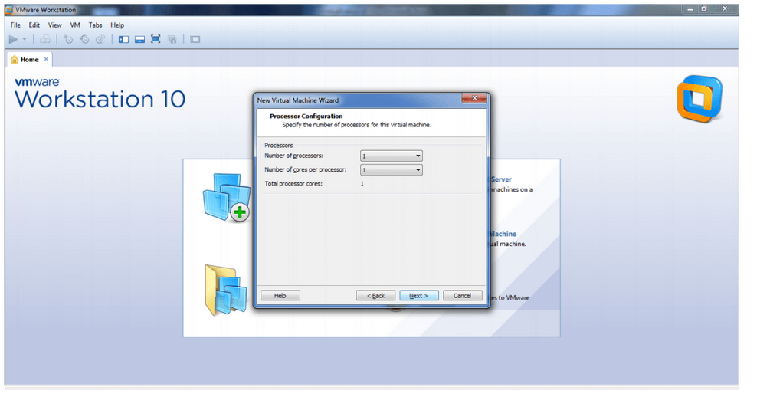
7) In the memory of the virtual machine window, you can set the memory limit. Click on the next button.
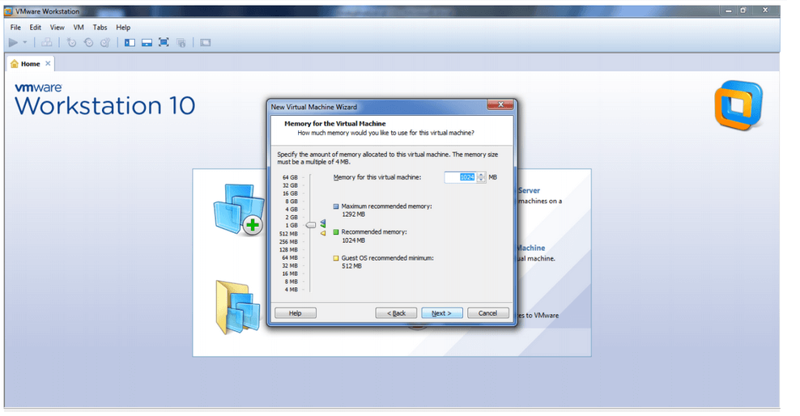
8) In the specify disk capacity window, you can set the disk size. Click on the next button.
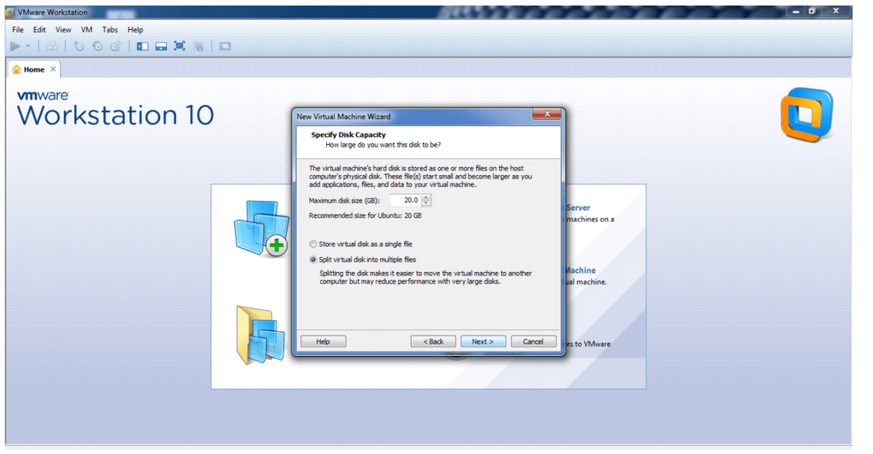
9) In the specify disk file window, you can specify the disk file then click on the next button.
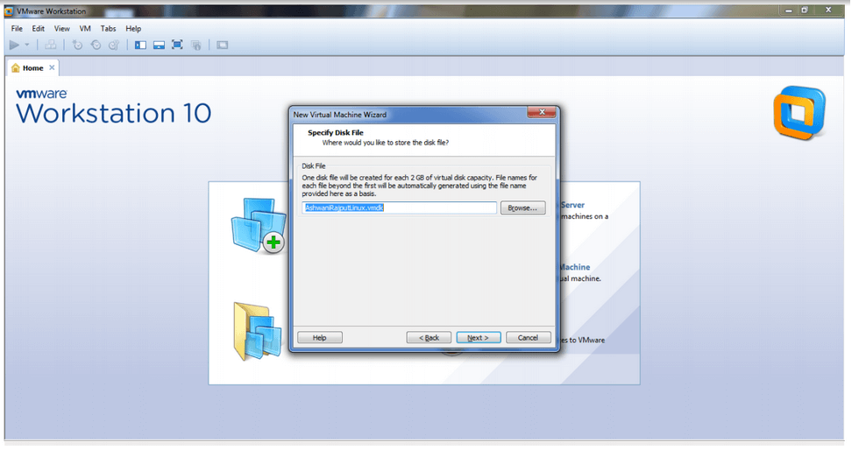
10) In the ready to create virtual machine window, click on the finish button.
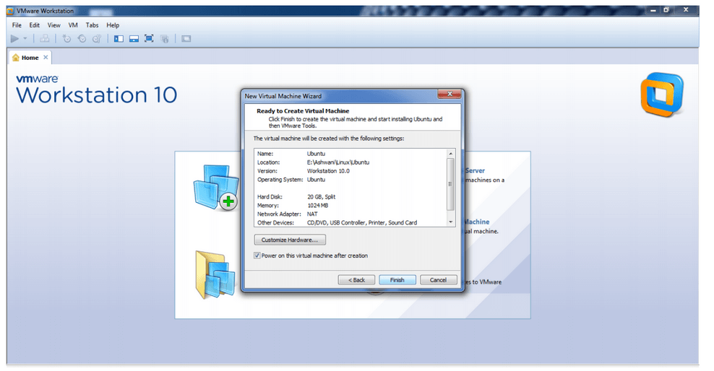
11) Now you will see vmware screen then ubuntu screen.

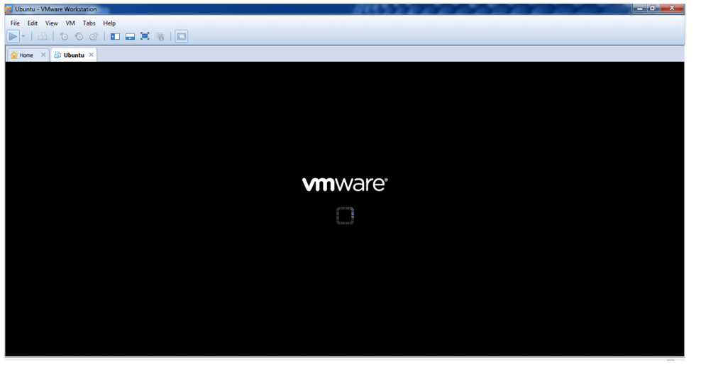 Windows OS Virutualization
To install windows OS virtually, you need to install VMware first. After installing virtualization software, you will get a window to install the new operating system.
Let's see the steps to install the windows OS on VMware workstation.
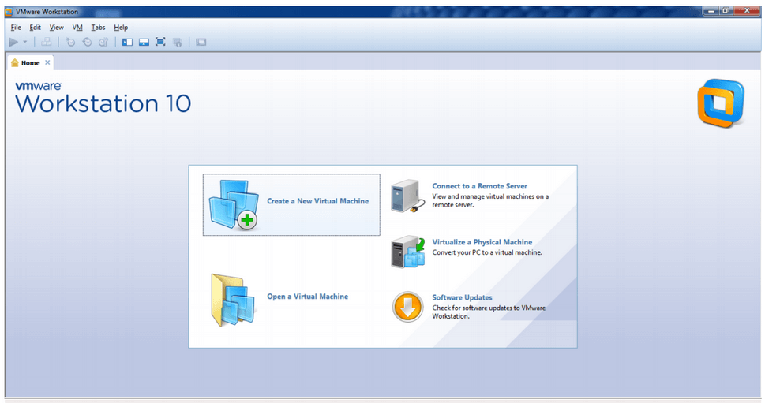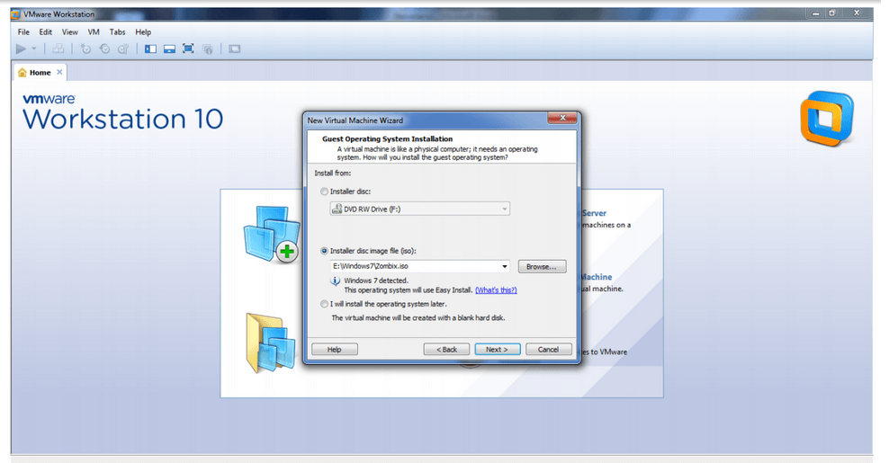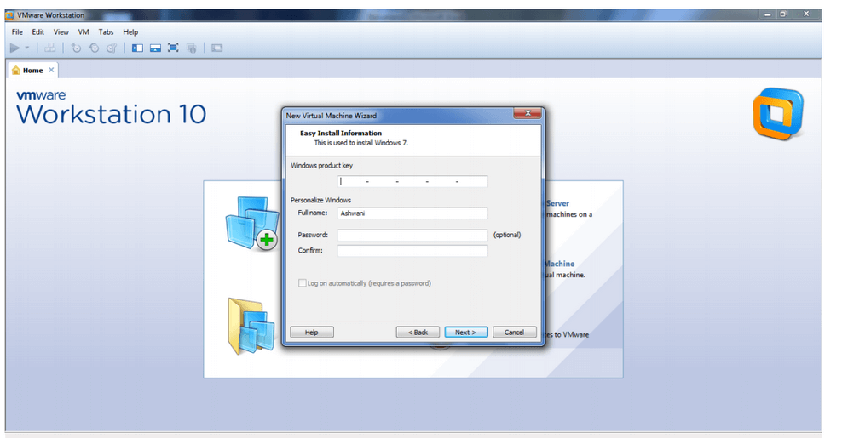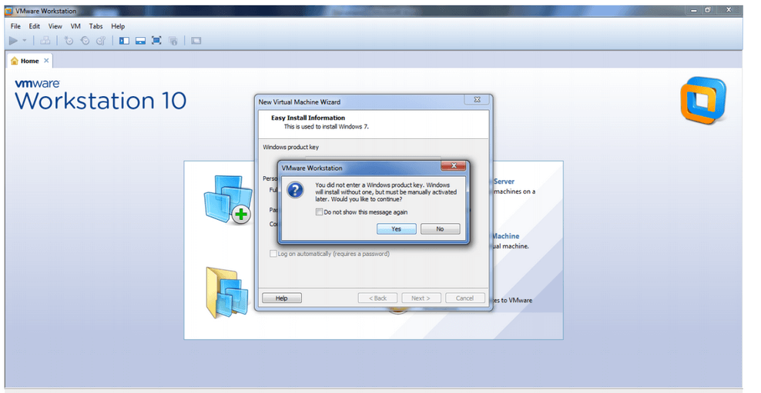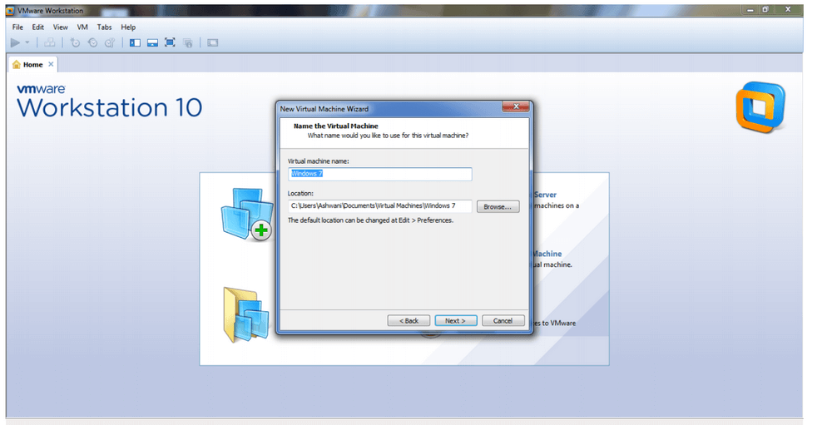
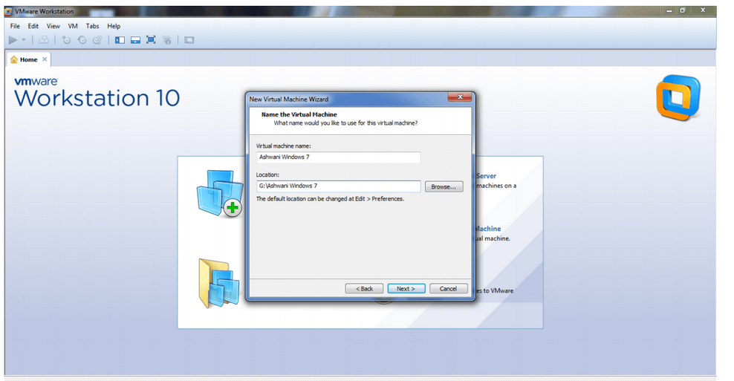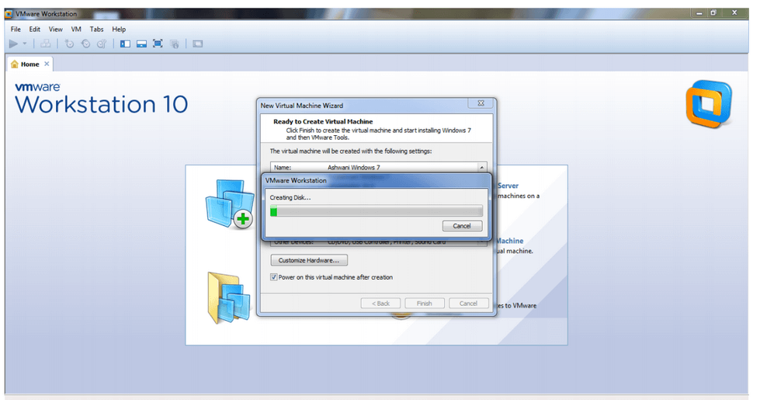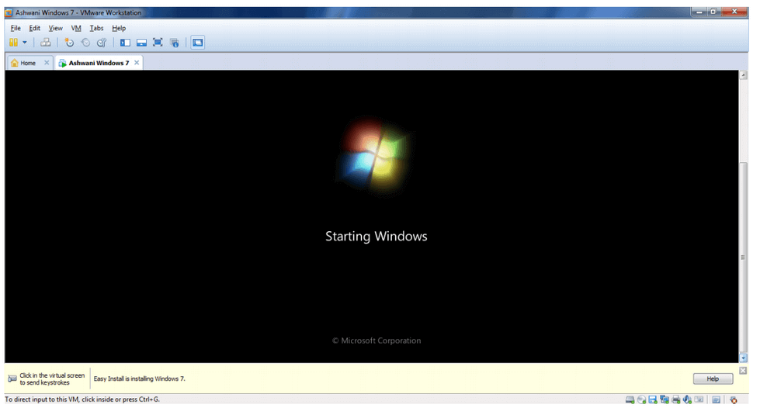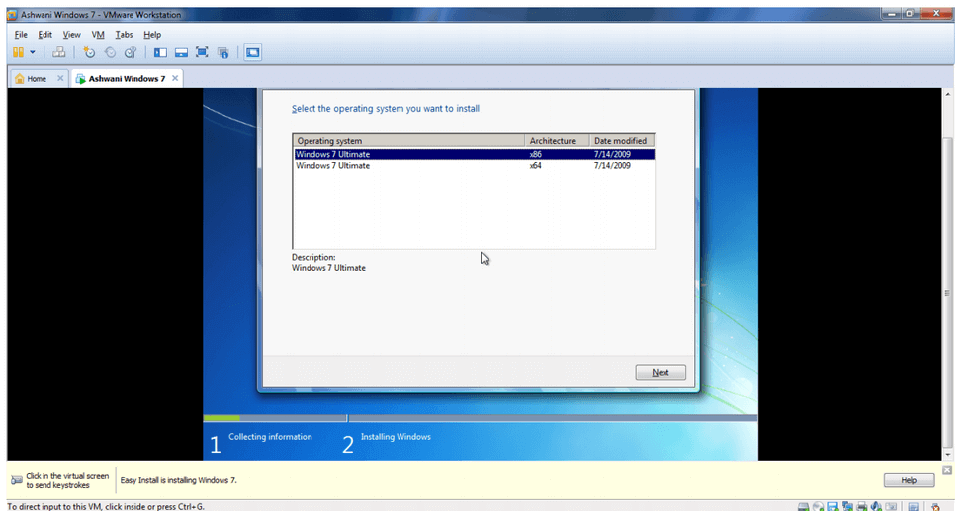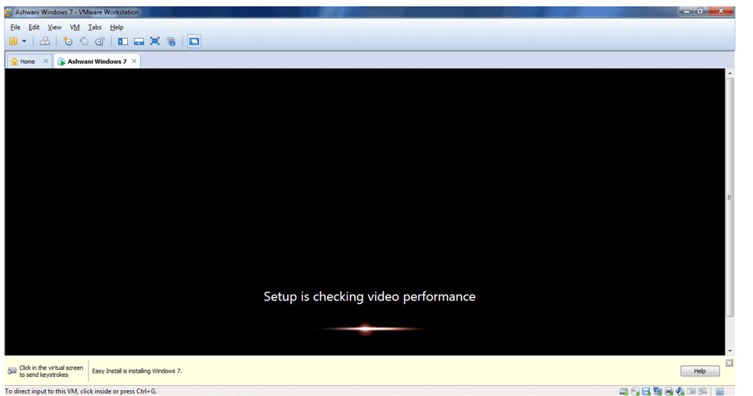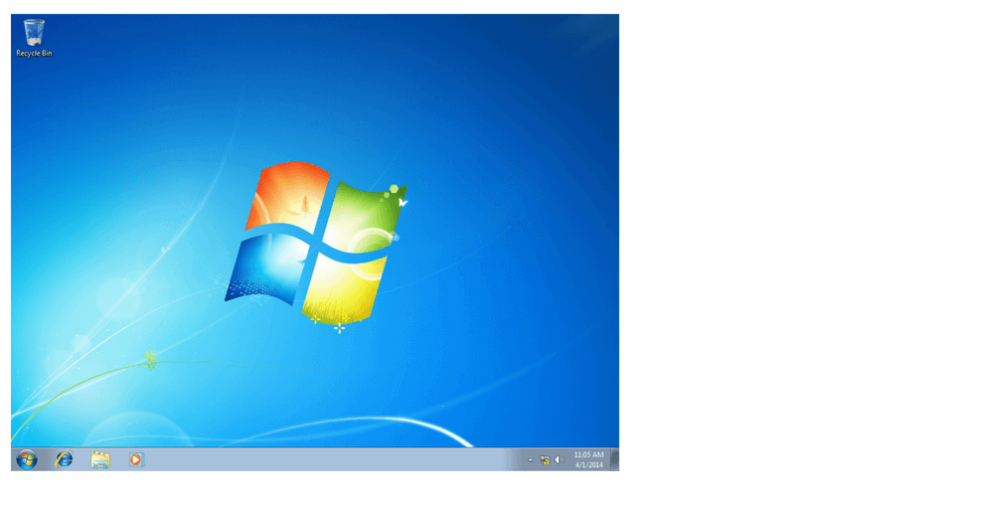

Next TopicCloud Service Provider Companies

